Final Project Report for EE264 Image Processing and Reconstruction

Retinex Image Enhancement Techniques—

Algorithm, Application and Advantages
Winter 2002 Quarter Mar. 16th, 2002

Prepared by: Zhixi Bian and Yan Zhang

Introduction

There are often serious discrepancy existing between the images and the direct observation of the real scenes. The human perception has natures of dynamic range compression and color rendition on the scenes. It can compute the details across a large range of spectral and lightness variations. So it is color constant. By comparison, the recorded films and other electric cameras, have no such computations before the scenes are recorded in the dynamic range limited media. Even with wide dynamic range imaging systems, the recorded images will not be seen same as real observation. This is because the dynamic range compression for perception of the recorded images is weaker than that for the scene itself. This could be explained as that in the real world, the wider angular extent helps to improve the dynamic range compression.

Land [1] first proposed the idea of Retinex as a model of lightness and color perception of the human vision. Obviously it is not only a model, but also could be developed to algorithms of image enhancement. Land gave more contributions on Retinex algorithm, evolving the concept from a random walk computation [2], to his latest version of a center/surround spatially opponent operation [3]. The center/surround opponent operation is related to the neurophysiological functions of neurons in the primate retina, lateral geniculate nucleus, and cerebral cortex. Hurlbert [4] studied the lightness theories and found that they have a common mathematical foundation. Also the leaning problems for artificial neural networks suggested a solution with center/surround form. But that is not enough. The human vision does not determine the relative reflectances, but rather content dependent relative reflectances for arbitrary illumination conditions.

Jobson and his coworkers [5] defined a single-scale Retinex (SSR), which is an implementation of center/surround Retinex. But depending on the special scale, It can either provide dynamic range compression (small scale) or tonal rendition (large scale). Superposition of weighted different scale SSR is obvious a choice to balance these two effects. This is multiscale Retinex (MSR) [6]. For color images, if the content is out of “gray world”, which means the spatial averages of three color bands are far from equal, the output will be forced to be gray by MSR. This problem could be solved by introducing weight factor for different channels in multiscale retinex with color restoration (MSRCR). After MSRCR, generally the outputs will be out of the range of display. Auto gain/offset can be used to shift and compressed the histogram of MSRCR outputs to the display domain. But the histograms of MSRCR outputs show typical shapes and the gain/offset parameters could be “canonical”.

In this project, we will implement SSR, MSR, and MSRCR with gain/offset. We adjust the gain/offset parameters to adjust most of the pixels values to display domain and clap small part of the values to improve the contrast. Comparisons with other image enhancement techniques will be made.

Single-scale retinex (SSR)

The Single-scale retinex is given by
(1)

Where Ii(x,y) is image distribution in the ith color band, F(x,y) is the normalized surround function.
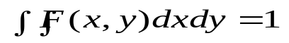
(2)

The image distribution is the product of scenes reflectance and illumination.
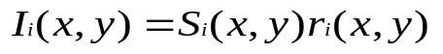
(3)

Where Si(x,y) is the spatial distribution of illumination and ri(x,y), the distribution of scene reflectances. The convolution with surround function works as averaging in the neighborhood. So that
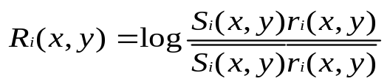
(4)

Generally the illumination has slow spatial variation, which means
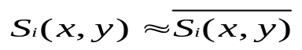
(5)

Then it will be apparent that color constancy ( i.e., independence from source illumination spectral and spatial variation) is achieved.
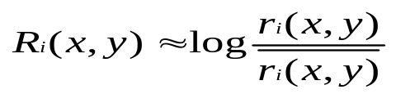
(6)

Various surround function could be used. Land proposed an inverse square spatial surround function,
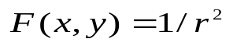
(7)

Moore suggested the exponential formula with absolute parameter,
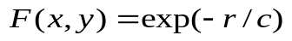
(8)

And Hurlbert studied the Gaussian,
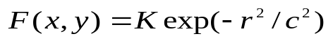
(9)

Jobson stated that Gaussian had the property of being more “regional” and offered good dynamic range compression over a large range of space constant. The selection of space constant is related with visual angel in the direct observation. But the value cannot be theoretically modeled and determined. Basically there is a trade-off between dynamic compression, (for example, details in the shadow), and color rendition. The middle of the range between 50 and 100 pixels represents a reasonable compromise.
Fig. 1 shows an original medical image and processed image with different scale of surround. It is clear that the dynamic range of original image is very large, and we cannot see anything in the shadow.
Fig. 2 is another medical example.

Multiscale Retinex (MSR)

Because of the tradeoff between dynamic range compression and color rendition, we have to choose a good scale c in the formula of F(x,y) in SSR. If we do not want to sacrifice either dynamic range compression or color rendition, multiscale retinex, which is a combination of weighted different scale of SSR, is a good solution,
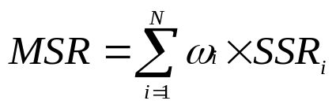
(10)

Where N is the number of the scales, Rni is the ith component of the nth scale. The obvious question about MSR is the number of scales needed, scale values, and weight values. Experiments showed that three scales are enough for most of the images, and the weights can be equal. Generally fixed scales of 15,80 and 250 can be used, or scales of fixed portion of image size can be used. But these are more experimental than theoretical, because we do not know the scale of image to the real scenes. The weights can be adjusted to weight more on dynamic range compression or color rendition. Fig. 3 and Fig. 4 are MSR results of previous medical examples. They have significant dynamic range compression in the boundary between the lighted parts and dark parts, and reasonable color rendition in the whole image scale.

- Color restoration method for MSR (MSRCR)

MSR is good for gray images. But it could be a problem for the color images because it does not consider the relative intensity of color bands. This can be seen from formula of MSR, whose output is the relative reflectances in the special domain. Considering the images “out of gray world”, whose average intensity for three color band are far from equal, the output of MSR for three channels will be more close, which make it looks more gray. The solution to this problem is to introduce weights for three color channels depending on the relative intensity of the three channels in the original images.
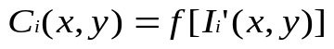
(11)

Where the relative intensity of three channels
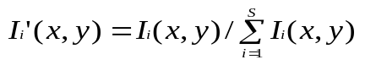
(12)

The color restoration function should be monotonic. Several linear and nonlinear functions were tried, Jobson found the best overall color restoration was

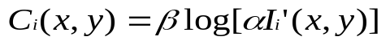
(13)

This color restoration method can be described as,
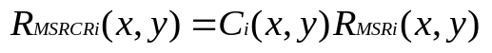
(14)

- MSRCR with gain/offset

Generally the output after MSRCR processing will be out of the display domain. It needs to be shifted and compressed to the display domain. People used the auto gain/offset method, where the gain and offset are based on the specified image statistics. But research showed that the histograms of different images got typical shape and position, which means the gain and offset parameters could be set once and run forever. Fig. 5 is the schematic of a characteristic retinex histogram. Because the pixel number with values at high and low regions are very small, clipping at suitable point can improve the contrast of the images and does not sacrifice information. Fig. 6 is an example of color image; we can not see the details in the shadow in original image. After MSR, the color is not good. After MSRCR with gain and offset, we can see the details in the shadow, although the color is not beautiful. In fact we cannot get this result with the reference’s parameters. We plot the histogram after MSRCR, and decided the clipping point, then calculated out the gain and offset to shift and compress the histogram of all three channels to the range between 0 and 255. When we decided the values of gain and offset, it showed it worked well for most of the images. Fig. 7 is another example.

Comparison with other state of art image processing techniques [7]

In order to analyze the advantages of the Retinex image enhancement techniques, we compare the retinex result with other image enhancement techniques, including auto gain/offset, gama correction, histogram equalization and homomorphic filtering. As a result, all the other techniques heavily depend on input images. For auto gain/offset, it could achieve dynamic range compression but at the loss of details due to saturation and clipping. For gama correction, it is good to improve pictures either too dark or too bright but it is a global function applied to the picture, thus there is no details enhancement involved. For histogram equalization and homomorphic filtering, they all failed for bi-modal pictures, which includes the information both dark and bright areas. (As Fig.8 but they all could achieve some better effect for Fig.9 since the picture is in a general dark situation. But for retinex, it could achieve satisfactory results for both pictures, thus its benefits are obviously to see.

Conclusion and future research suggestions

Multiscale retinex is an effective algorithm of retinex. It can have dynamic range compression and color rendition effects at the same time. For color images, color restoration is necessary in the case that the three-color channels are not intensity balanced. The gain/offset processes are used to shift, compress and clip the output of MSRCR to the display domain, which will improve the contrast. And one of the important characteristics of MSRCR with gain/offset algorithms is “canonical”, which means that the parameters of number of scales, scales, gain and offsets do not vary from image to image or between band to band.
As compared with other image enhancement techniques, the Retinex enhancement has the following advantage: 1. “Canonical” constant – once it is defined, image enhancement is an automatic process independent of inputs; 2. Has general application on all pictures; 3. Good dynamic range compression and color rendition effect.
For the future work, the color image should be further analyzed. Study the chapter 6 of the textbook “Digital Image Processing”, try to analyze the color model suitable for the retinex enhancement to improve the color correction function (Ci(x,y)) to achieve the better color rendition, at the same time, the empirical values of gain (G), offset (b) could also be improved.

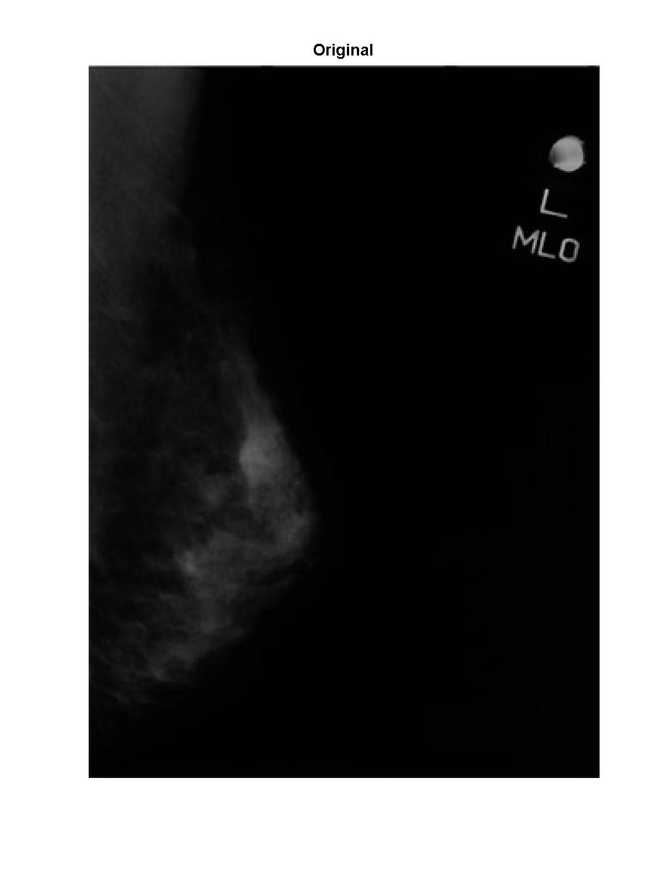
Fig.1 (a) Original image (432x310)

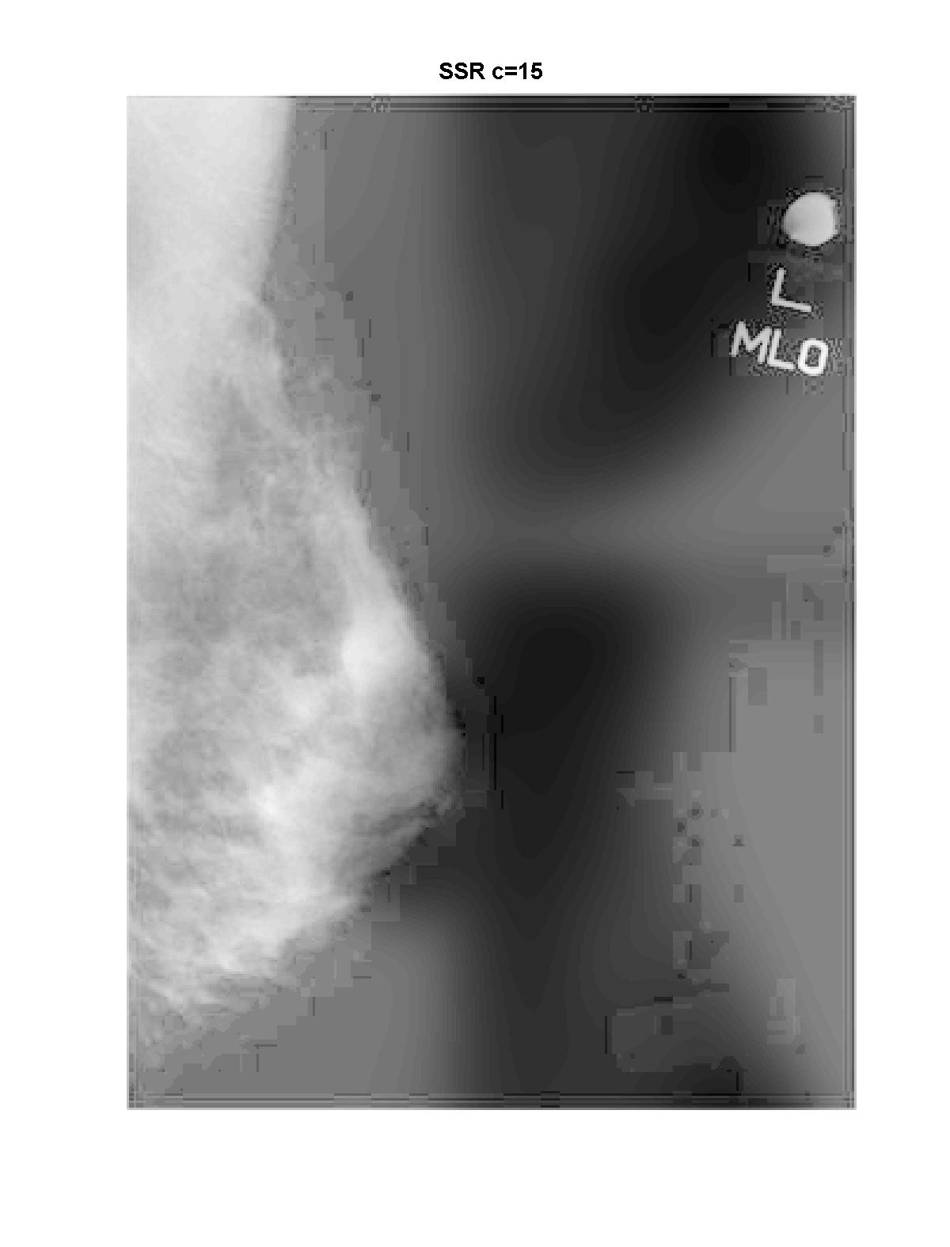

Fig.1 (b) SSR with scale 15

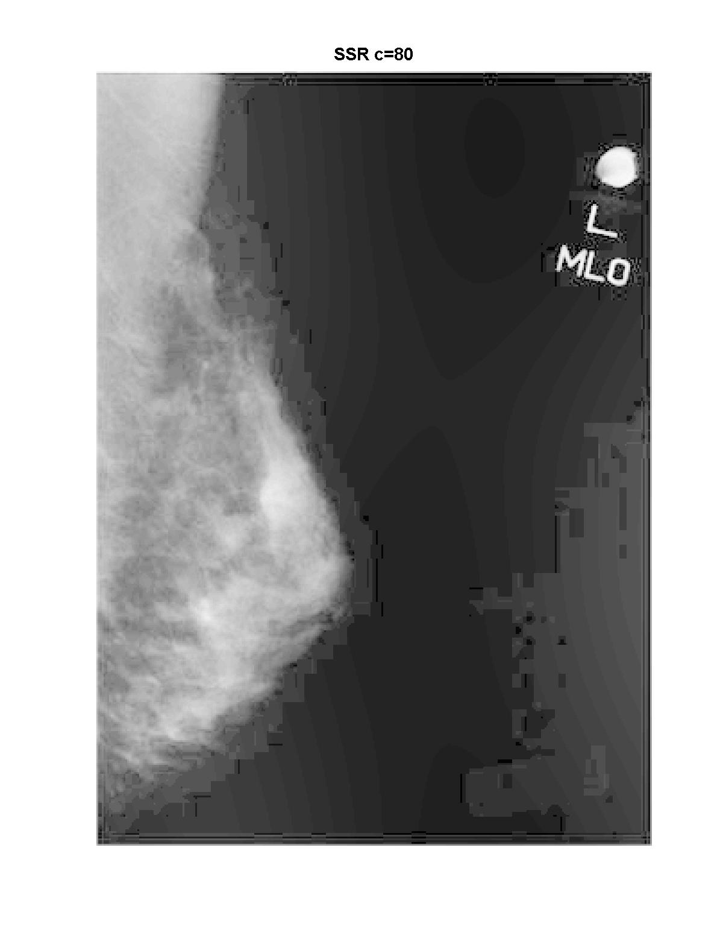

Fig.1 (c) SSR with scale 80

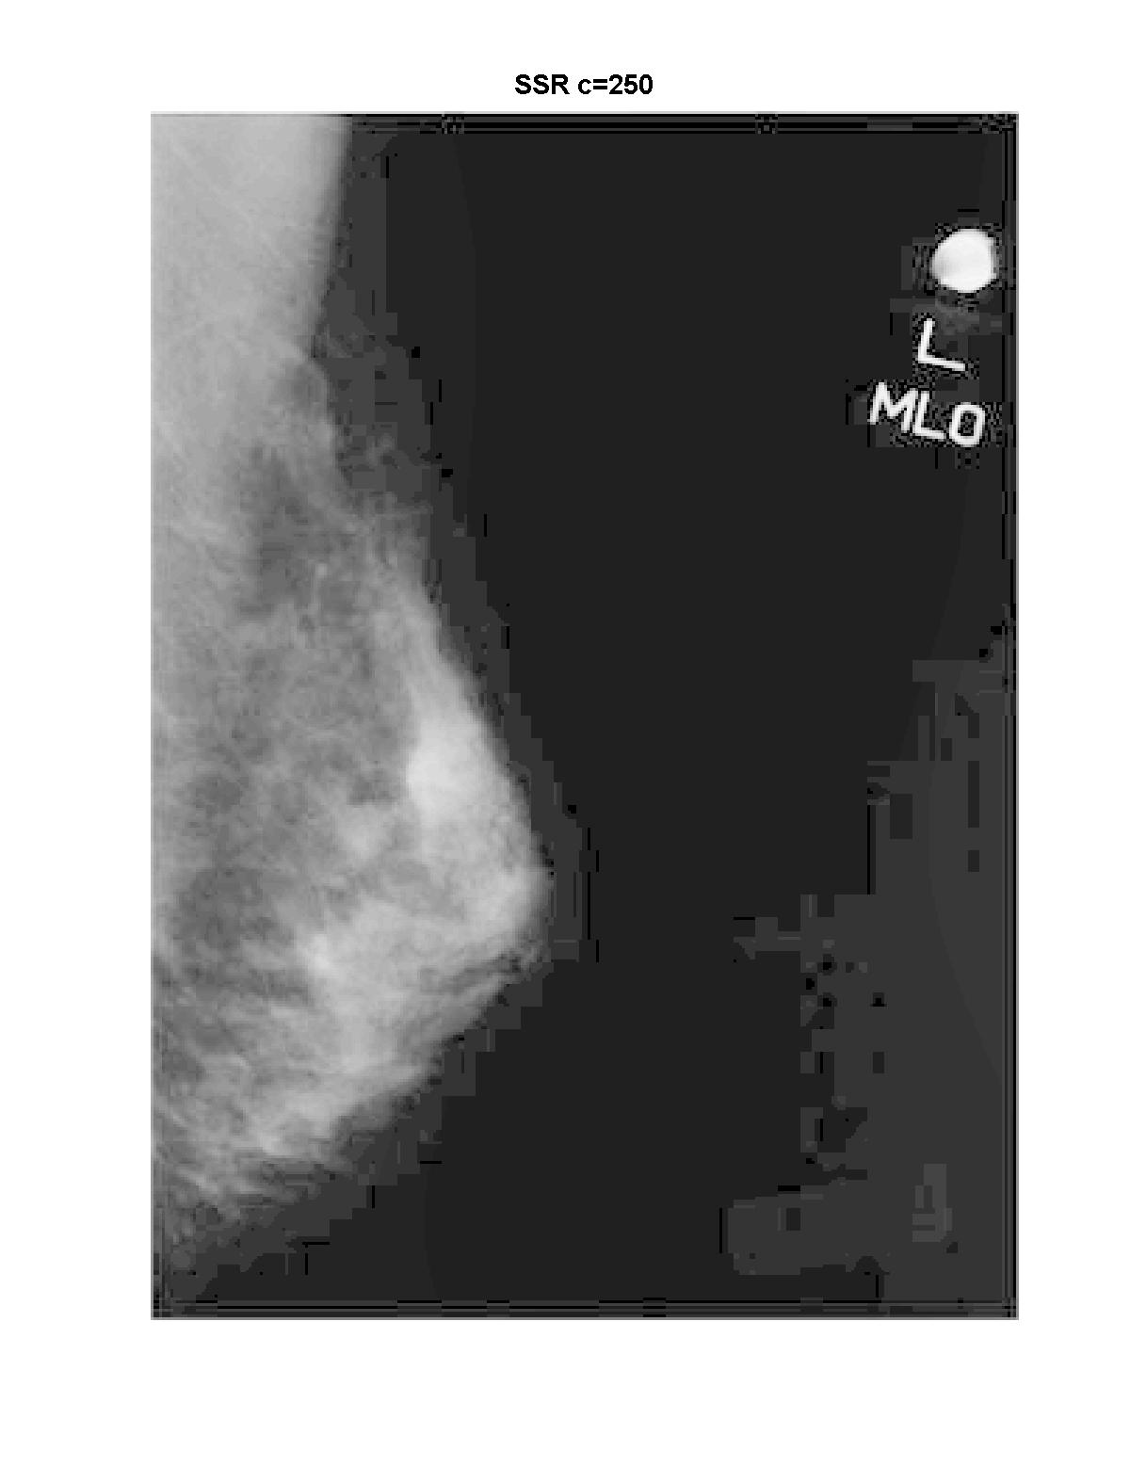

Fig.1 (d) SSR with scale 250

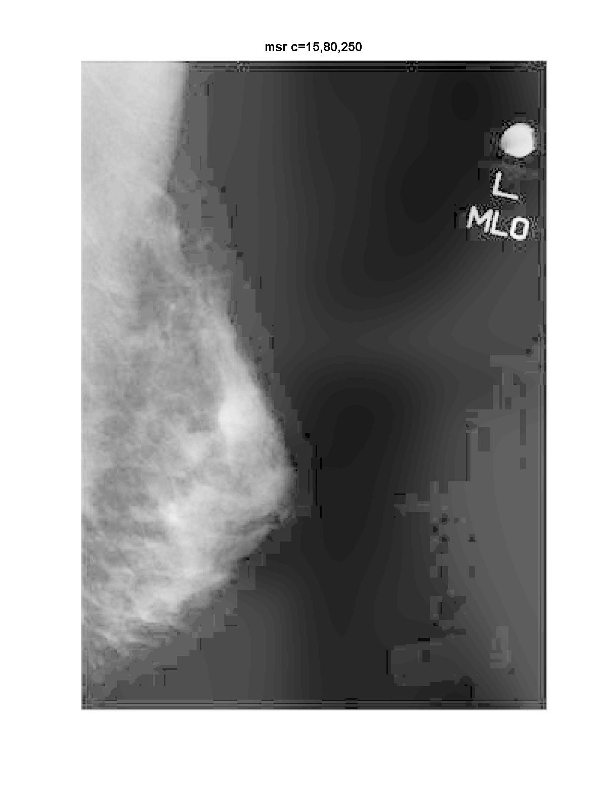

Fig.1 (e) MSR with scale 15,80,250

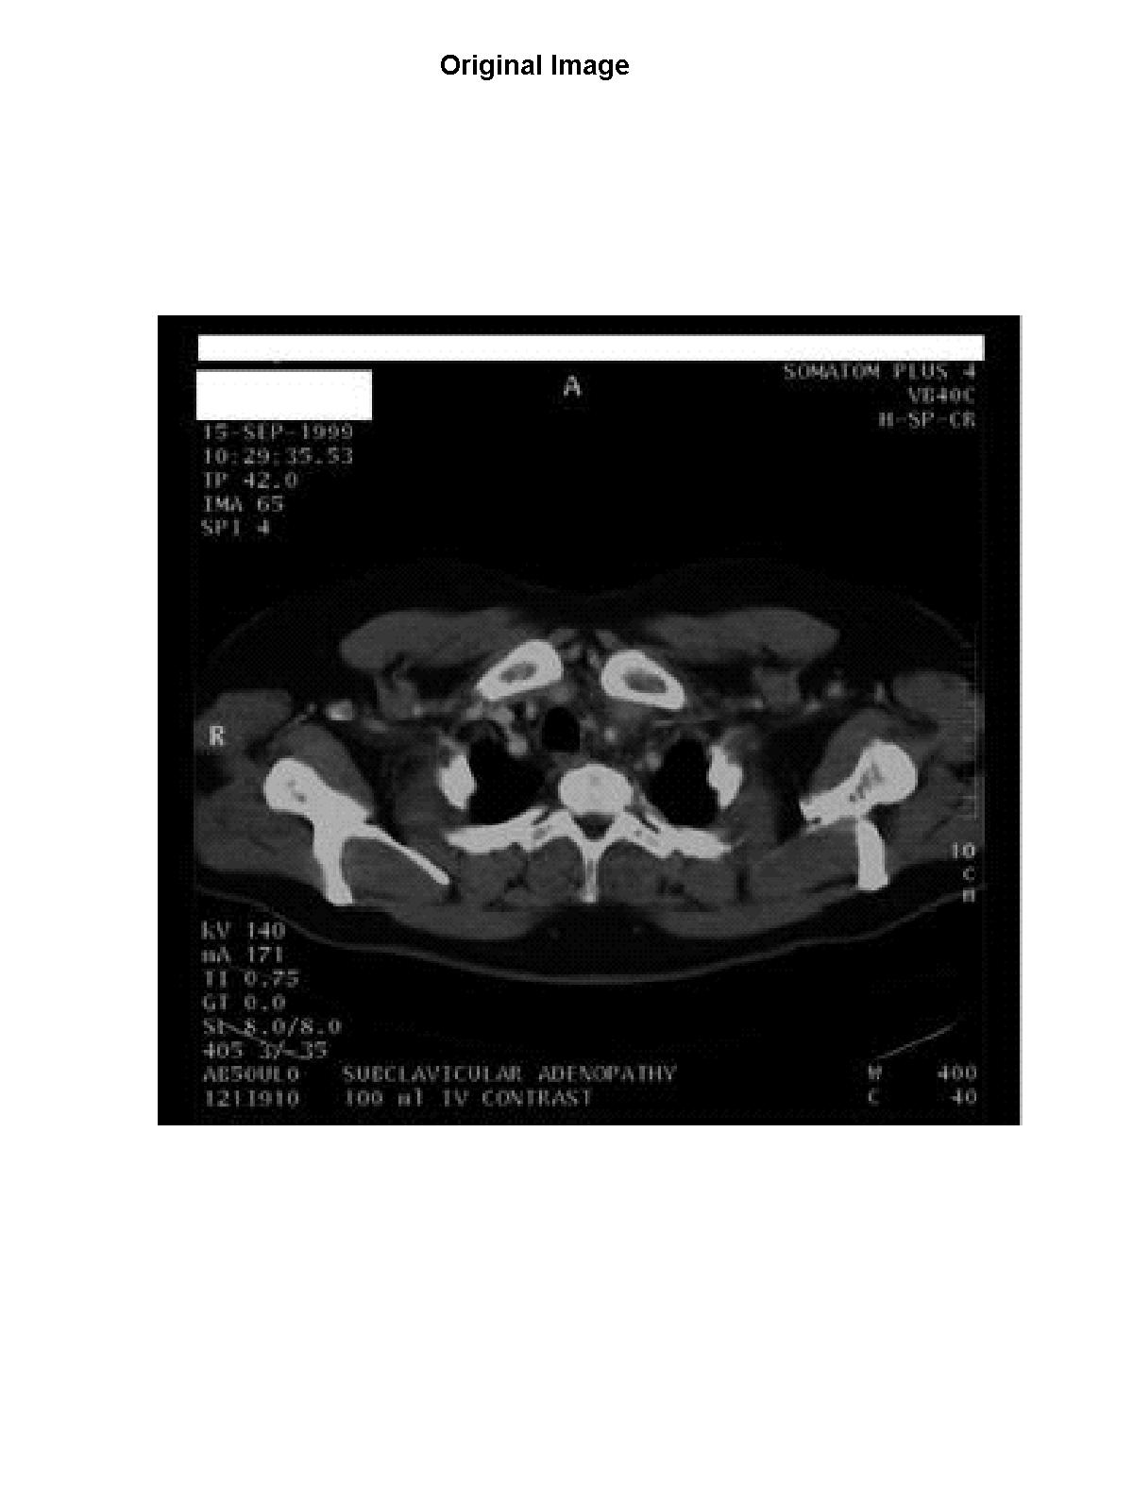
Fig. 2 (a) Original image (304x325)

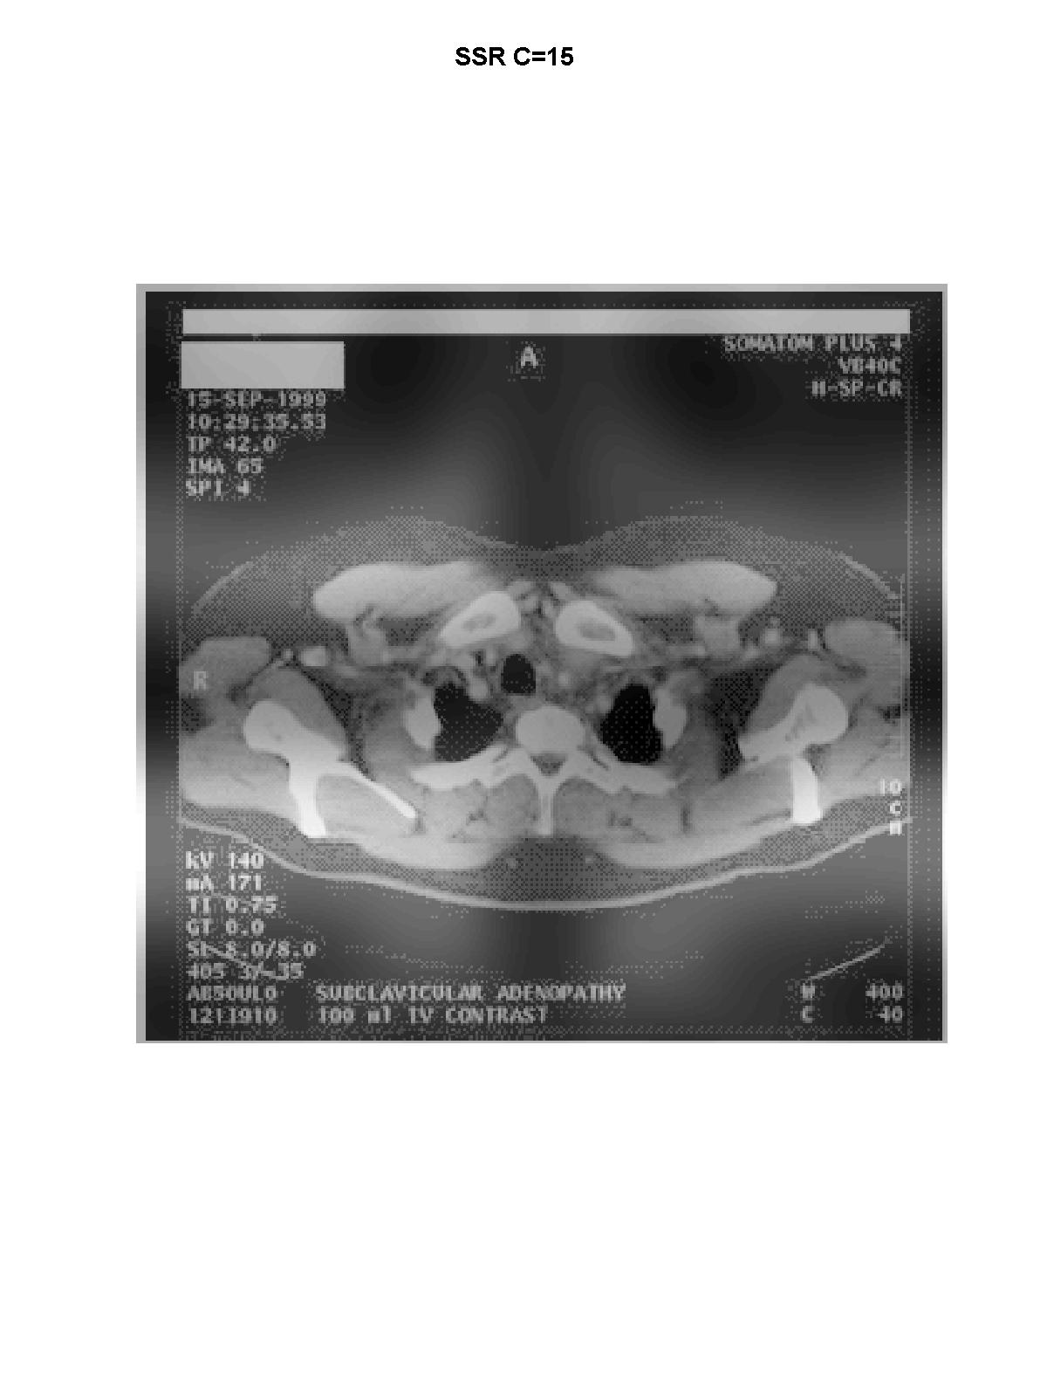
Fig.2 (b) SSR with scale 15

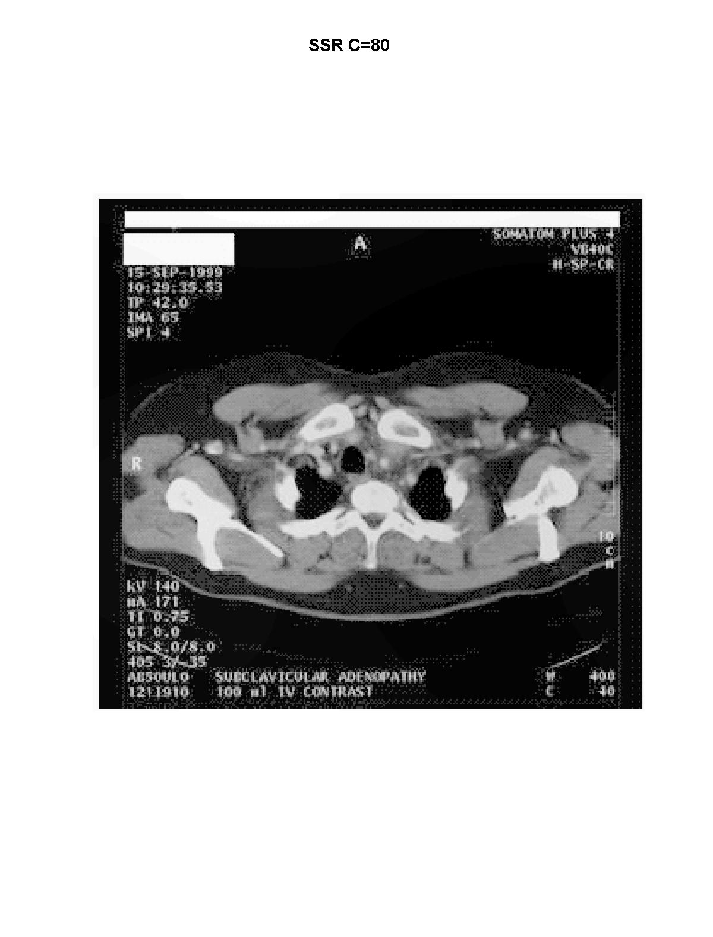
Fig.2 (c) SSR with scale 80

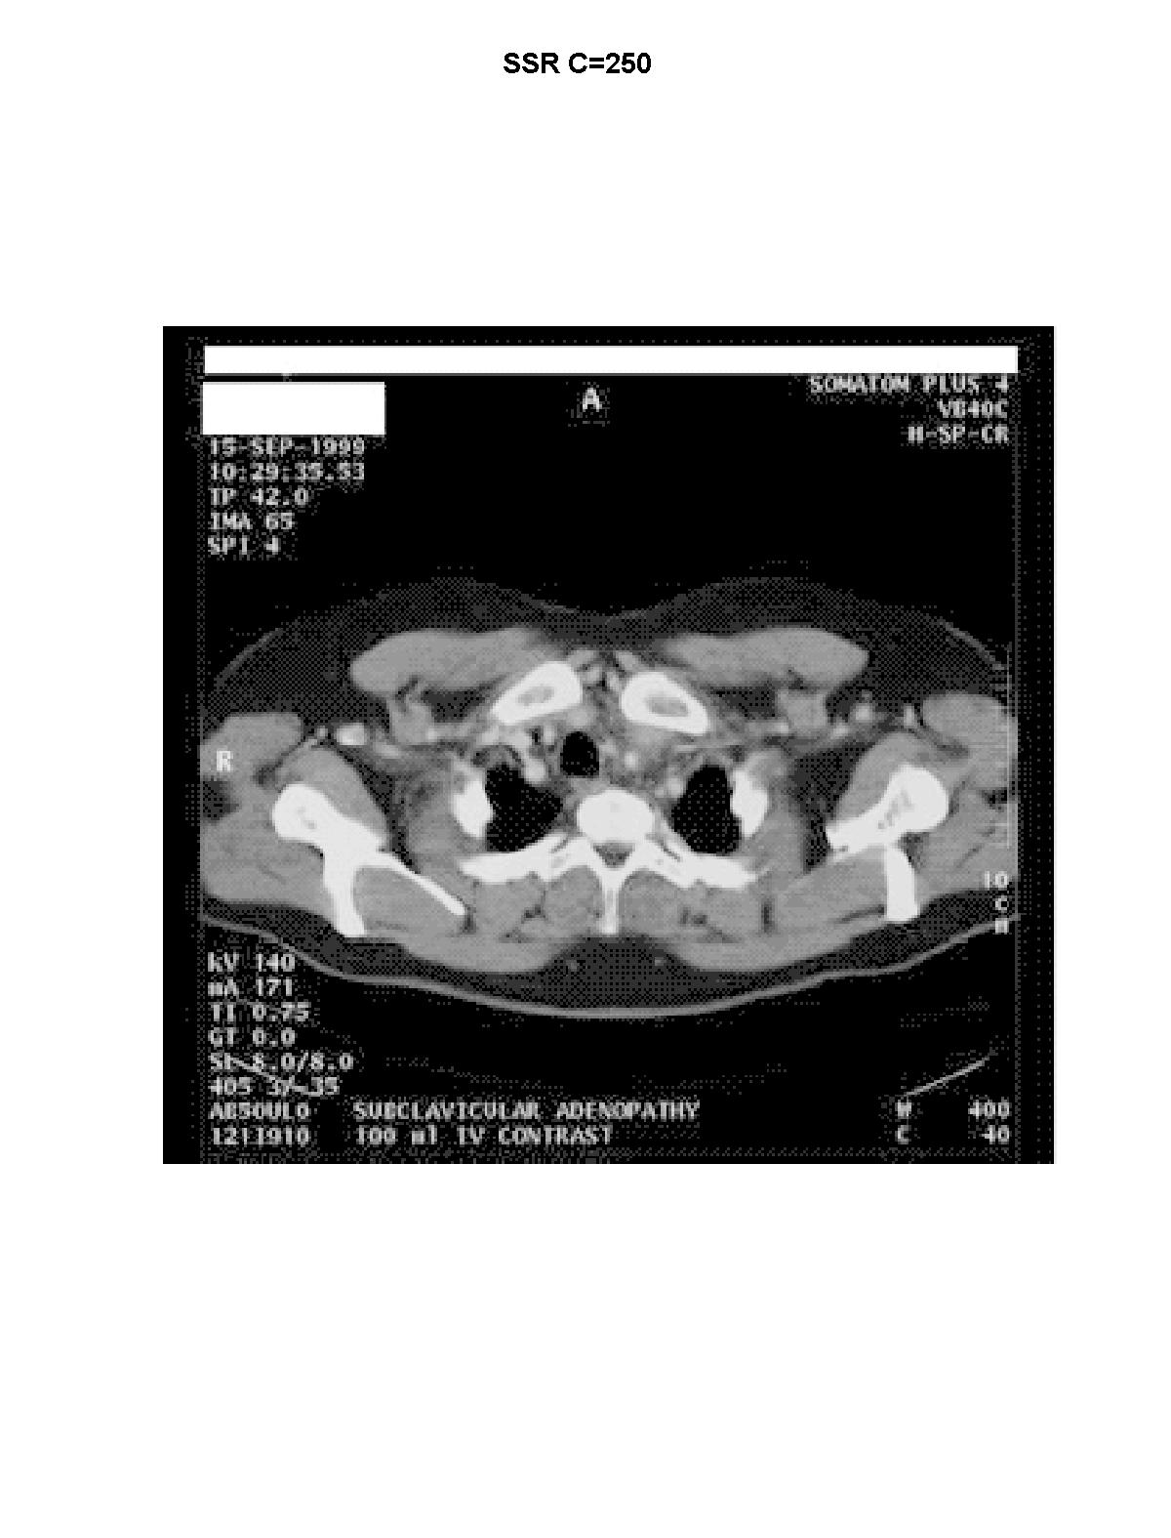

Fig.2 (d) SSR with scale 250
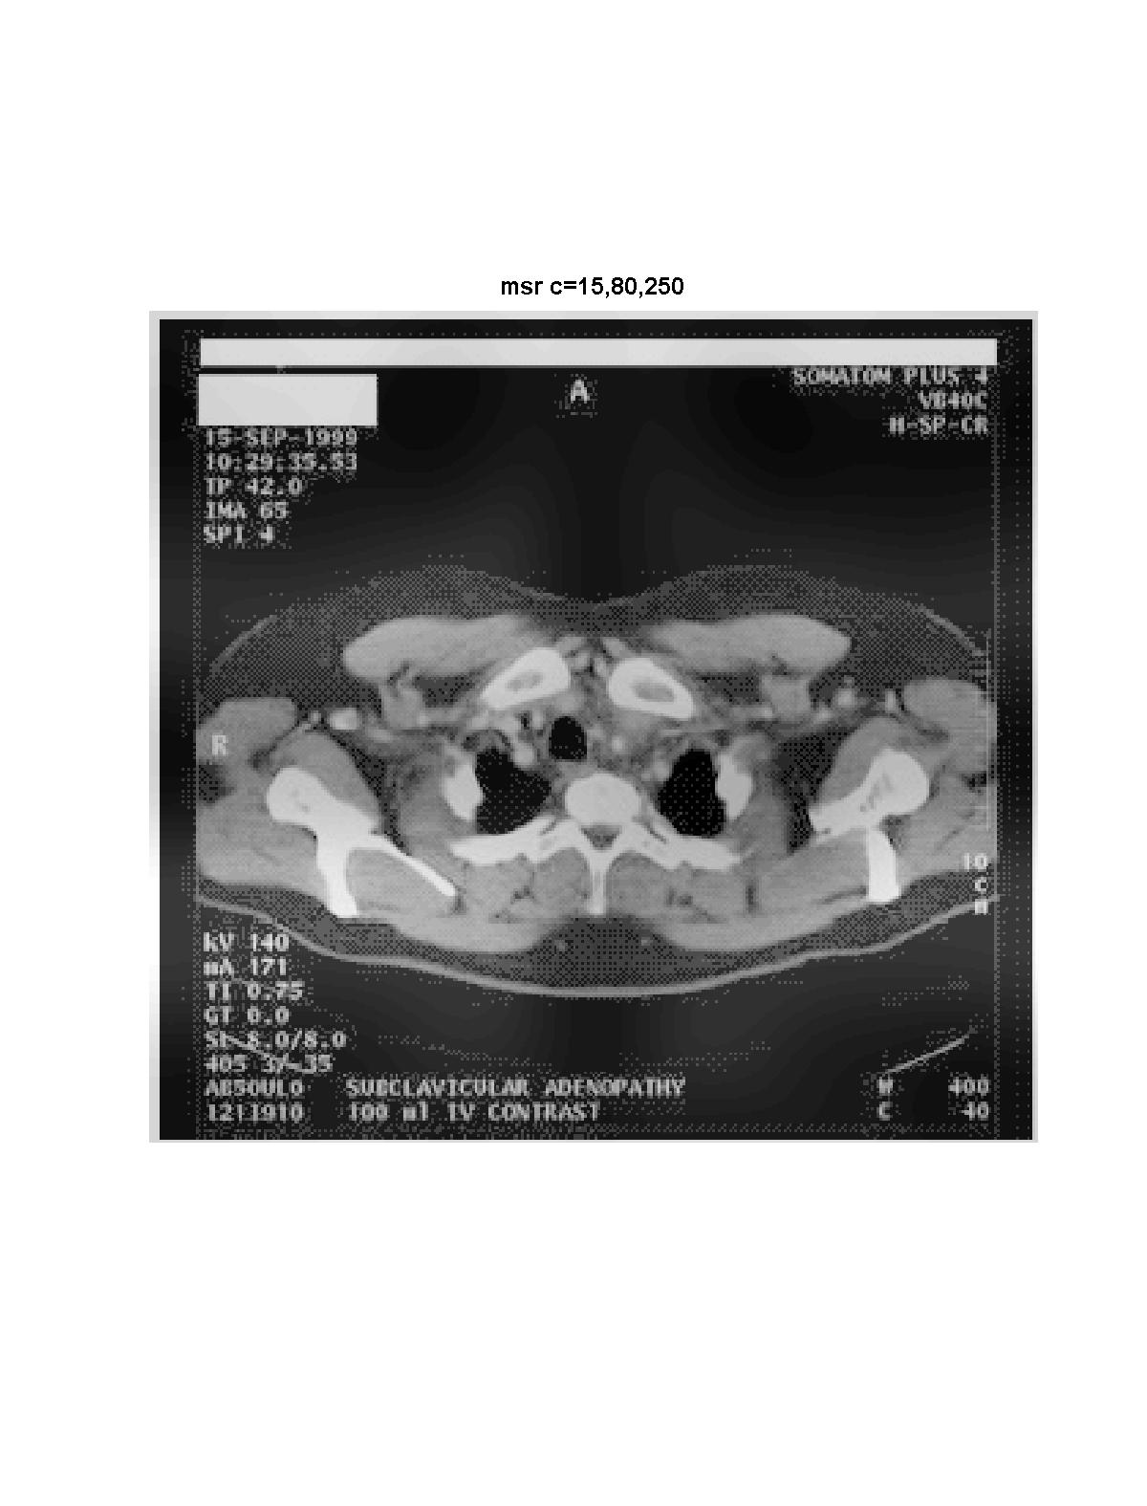

Fig.2 (e) MSR with scales 15,80,250

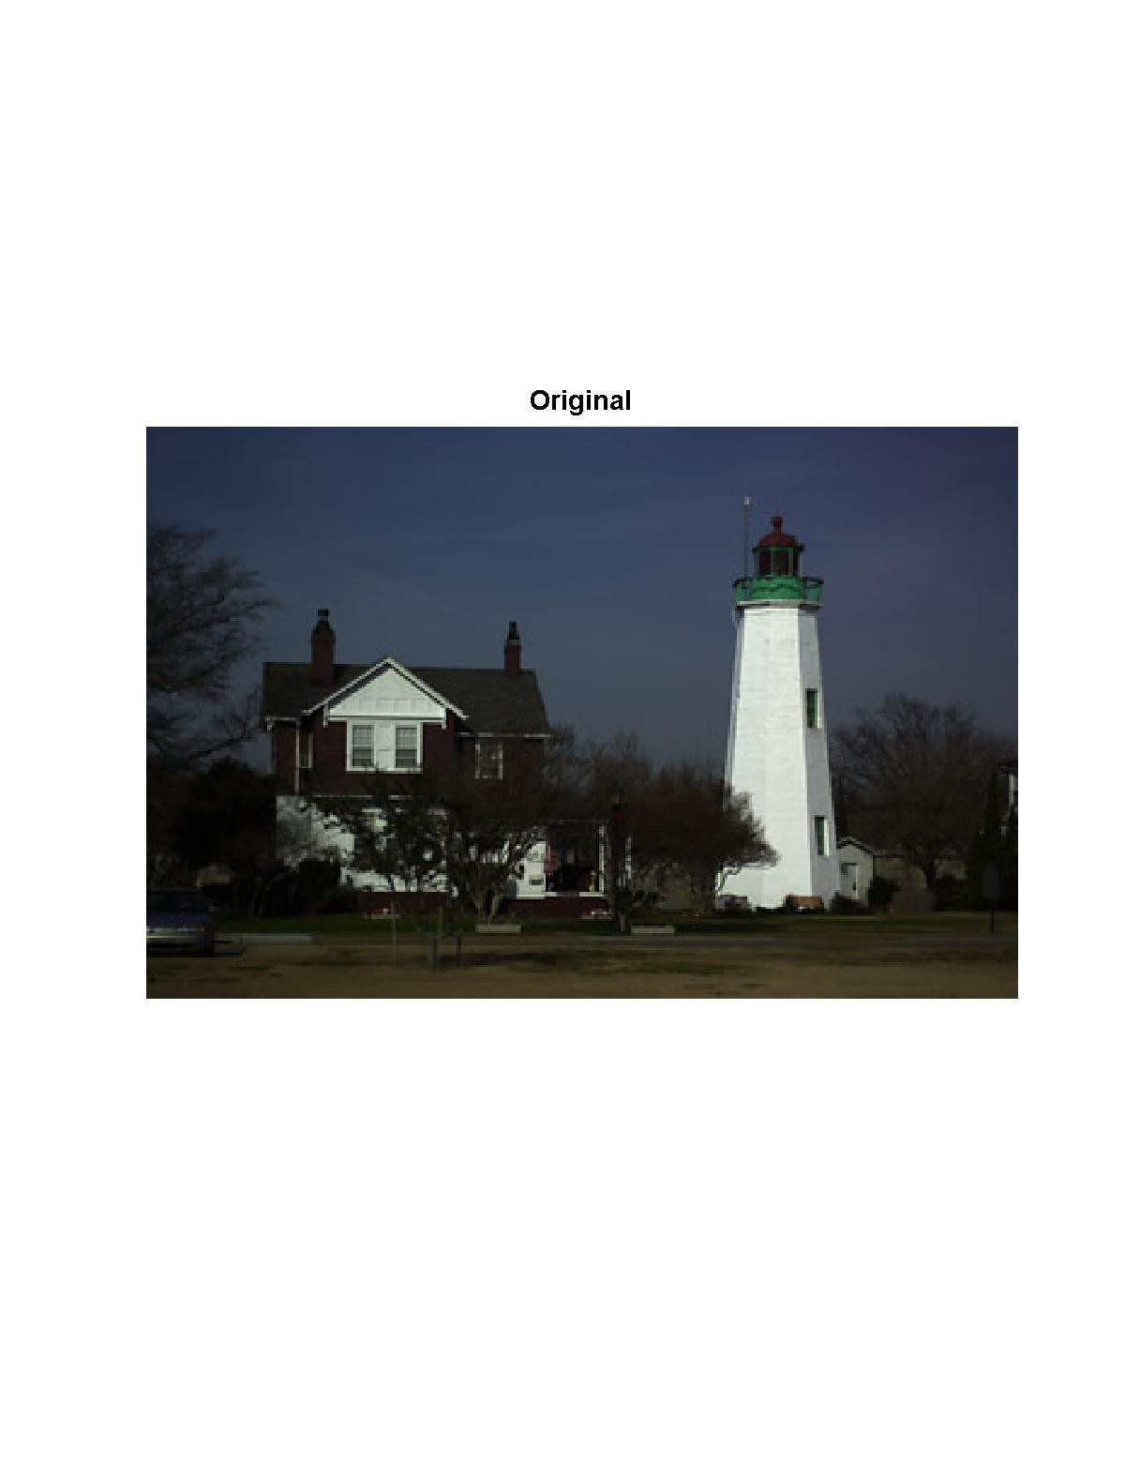

Fig.3 (a) Original image (236x360x3)

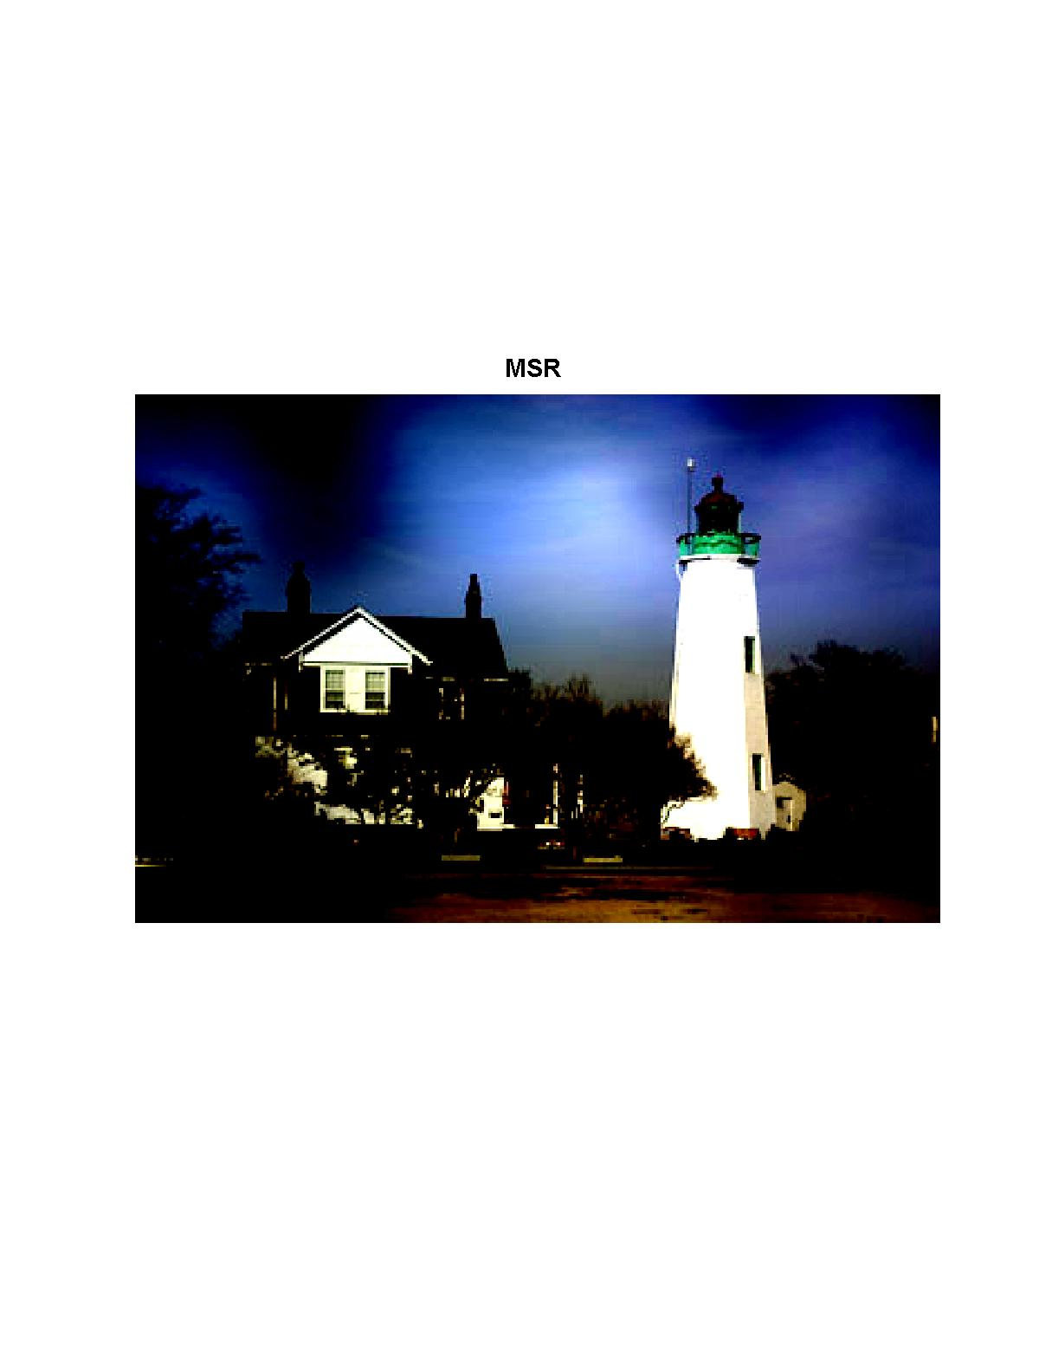

Fig.3 (b) MSR with scales 15,80,250

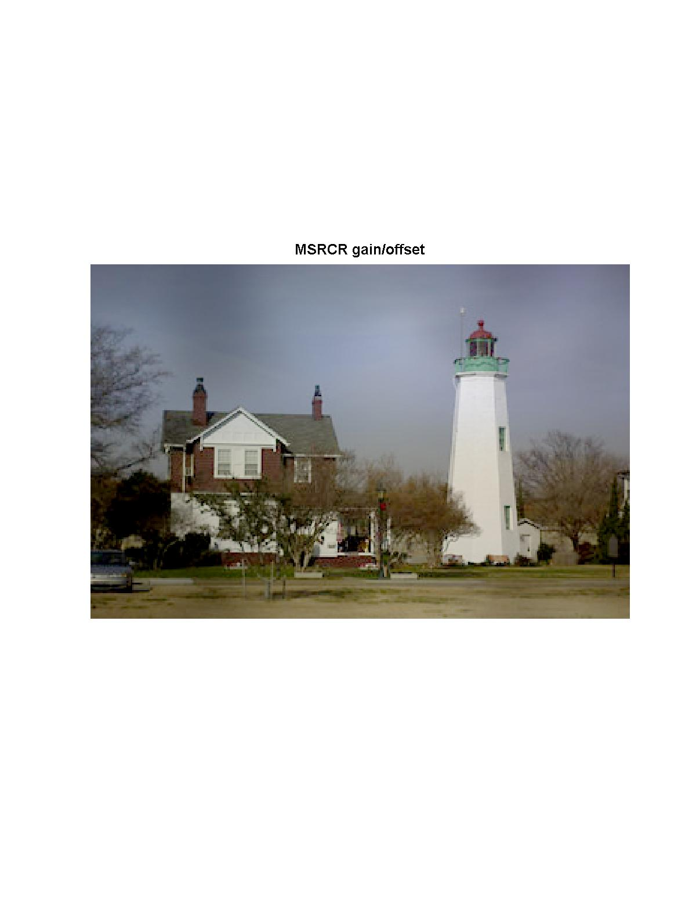
Fig.3 (c) MSRCR with gain/offset, scales 15,80,250

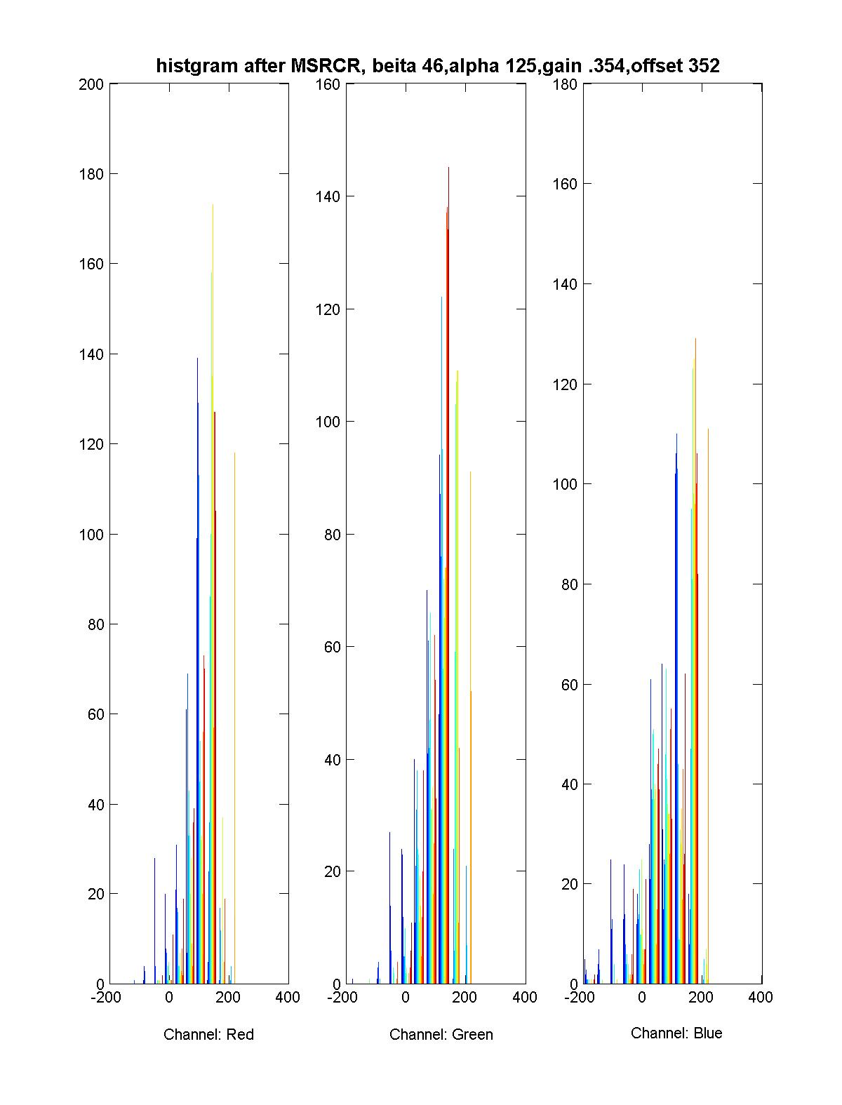

Fig.3 (d) histogram after MSRCR with gain/offset

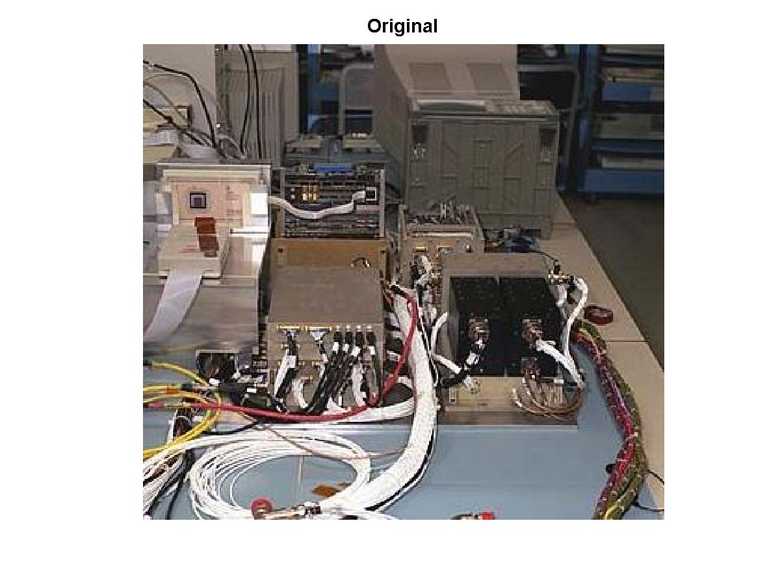

Fig.4 (a) Original image (316x346)

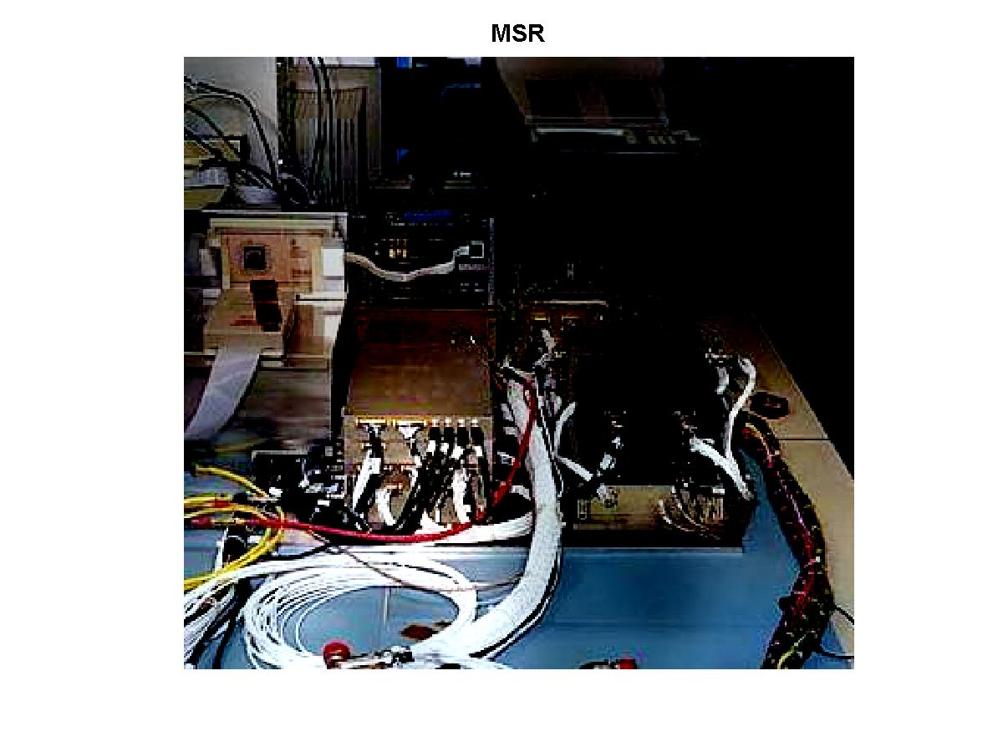

Fig.4 (b) MSR scales 15,80,250

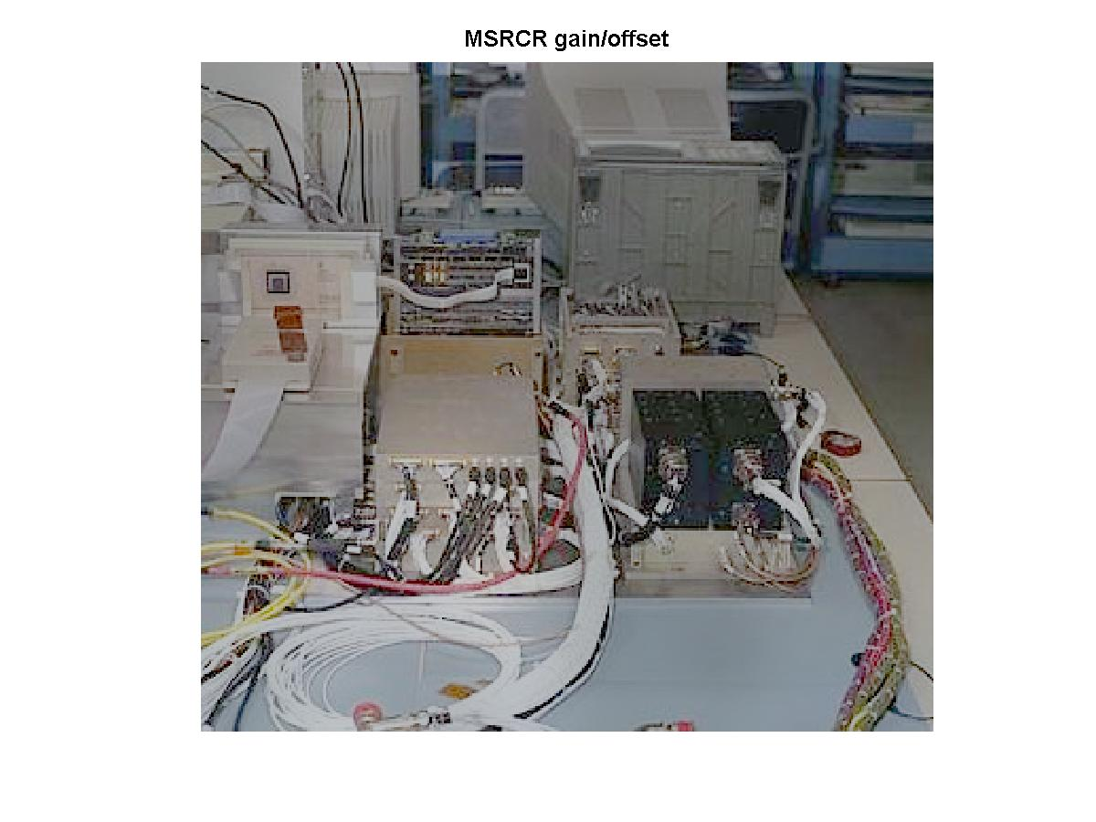

Fig.4 (c) MSRCR with gain/offset

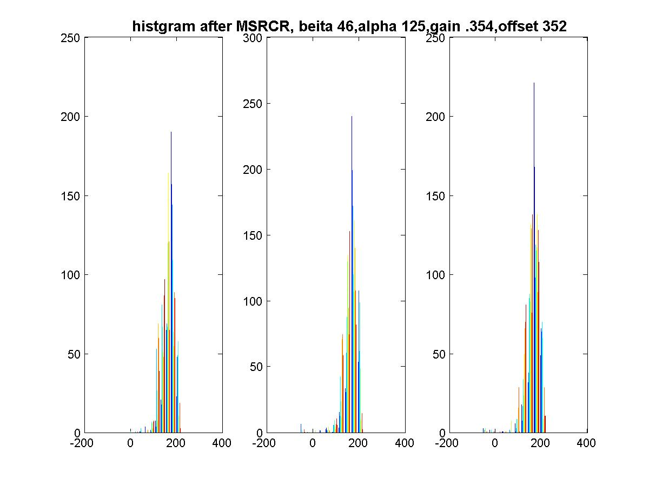

Fig.4 (d) Histogram after MSRCR with gain/offset

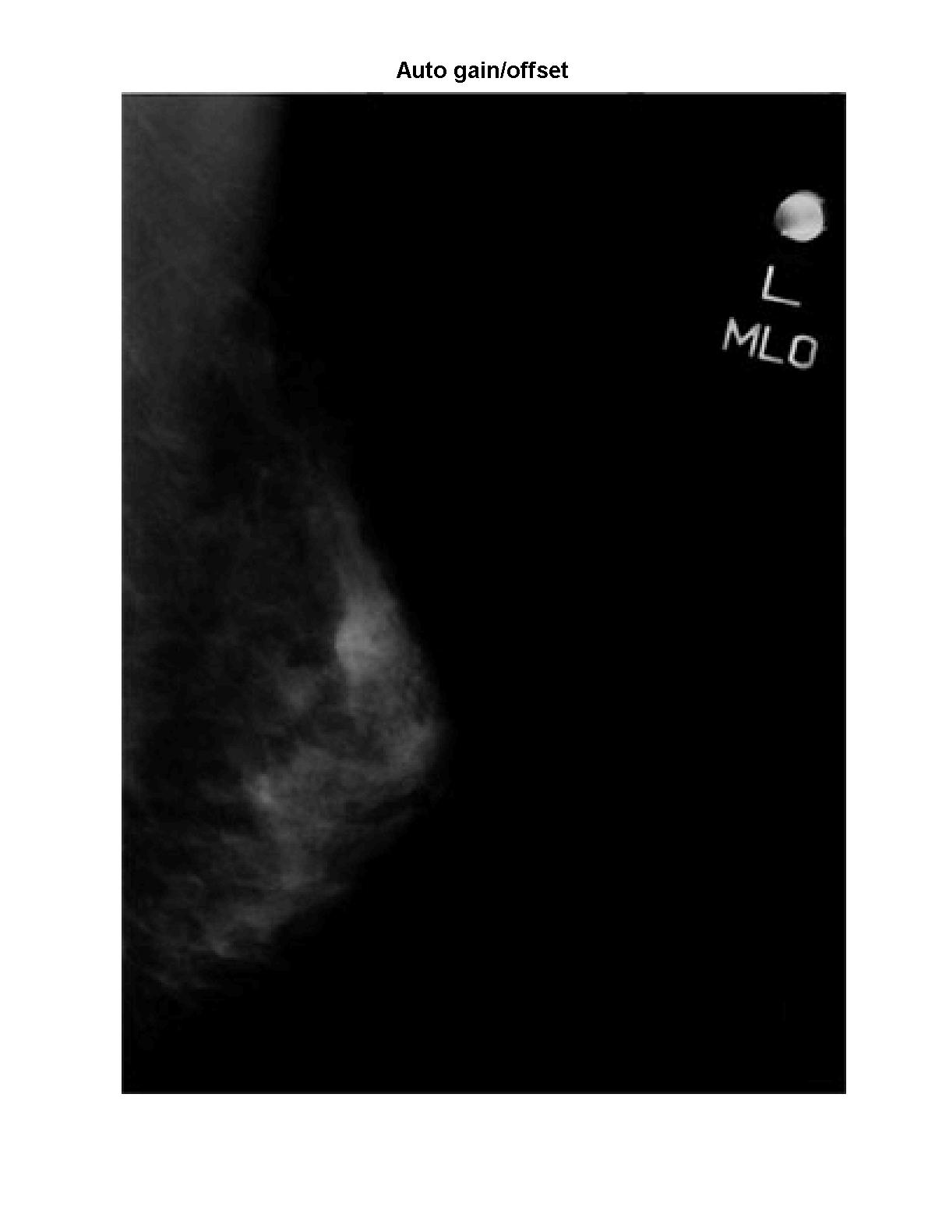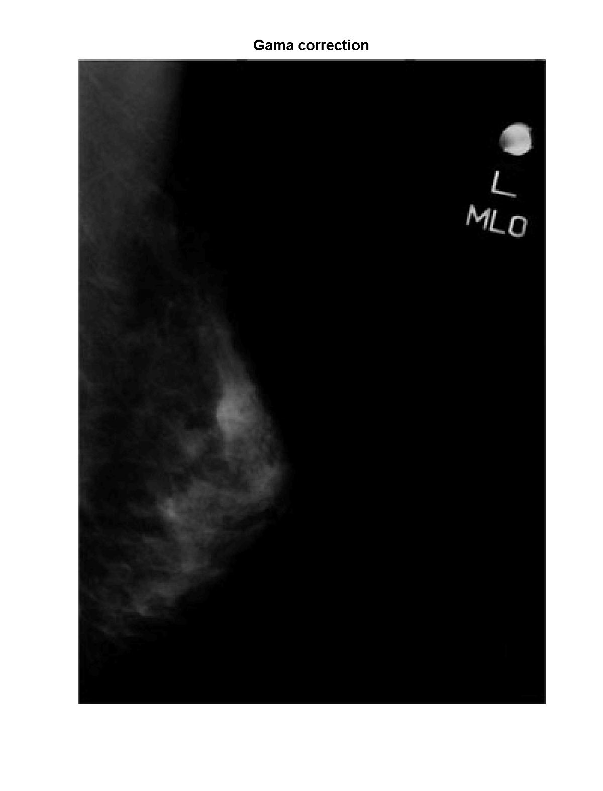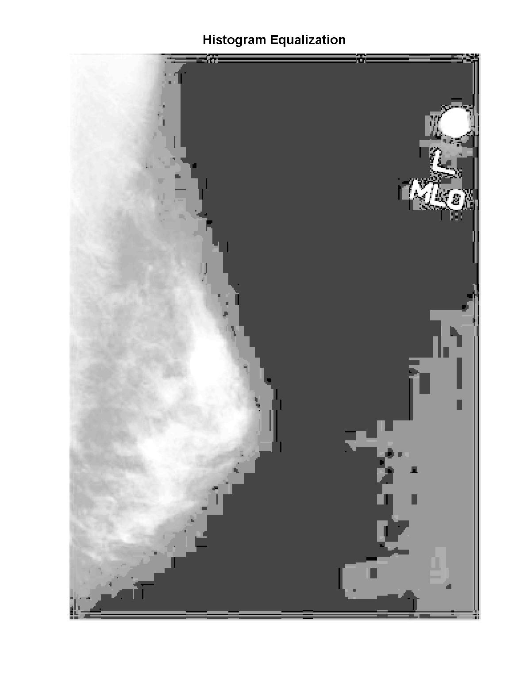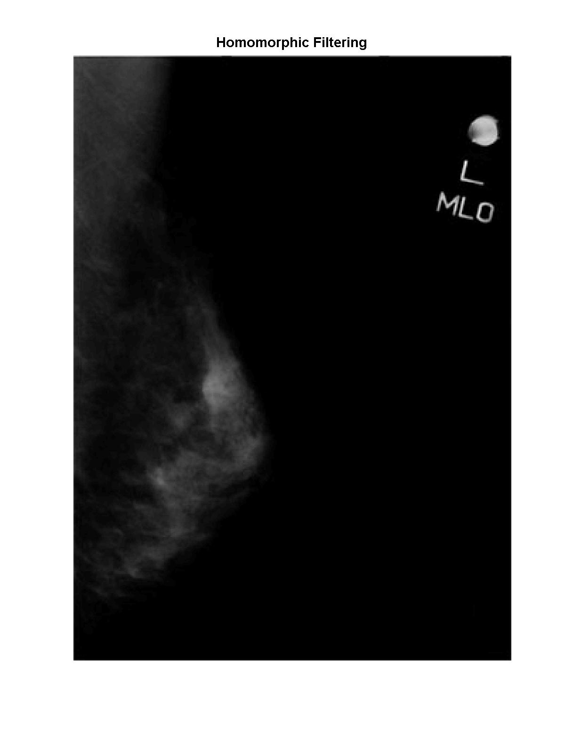
Fig. 5 Comparison of Retinex with other techniques (Example 1)
a
b
c
d
b
f
- original image b) Retinex enhanced image c) Auto gain/offset d) Gama Correction e) Histogram equalization; f)Homomorphic filtering

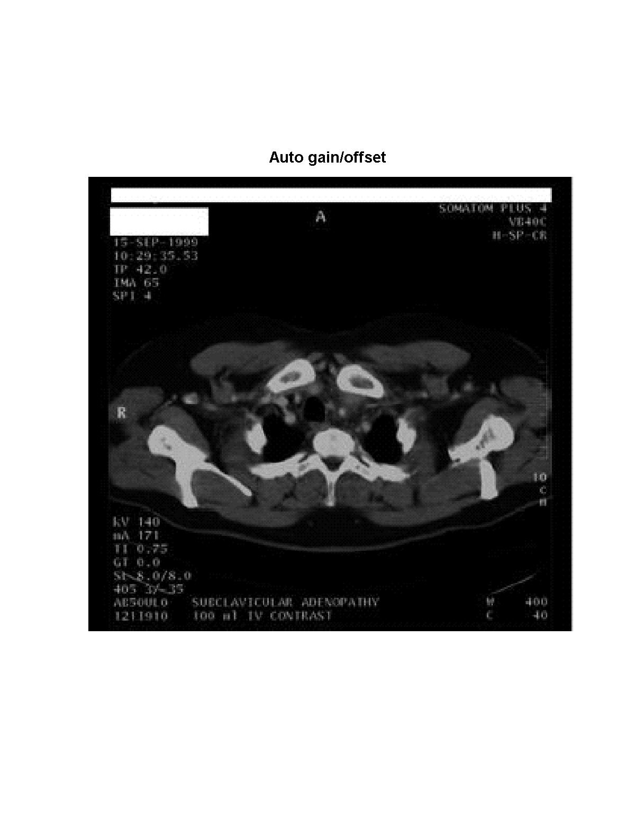
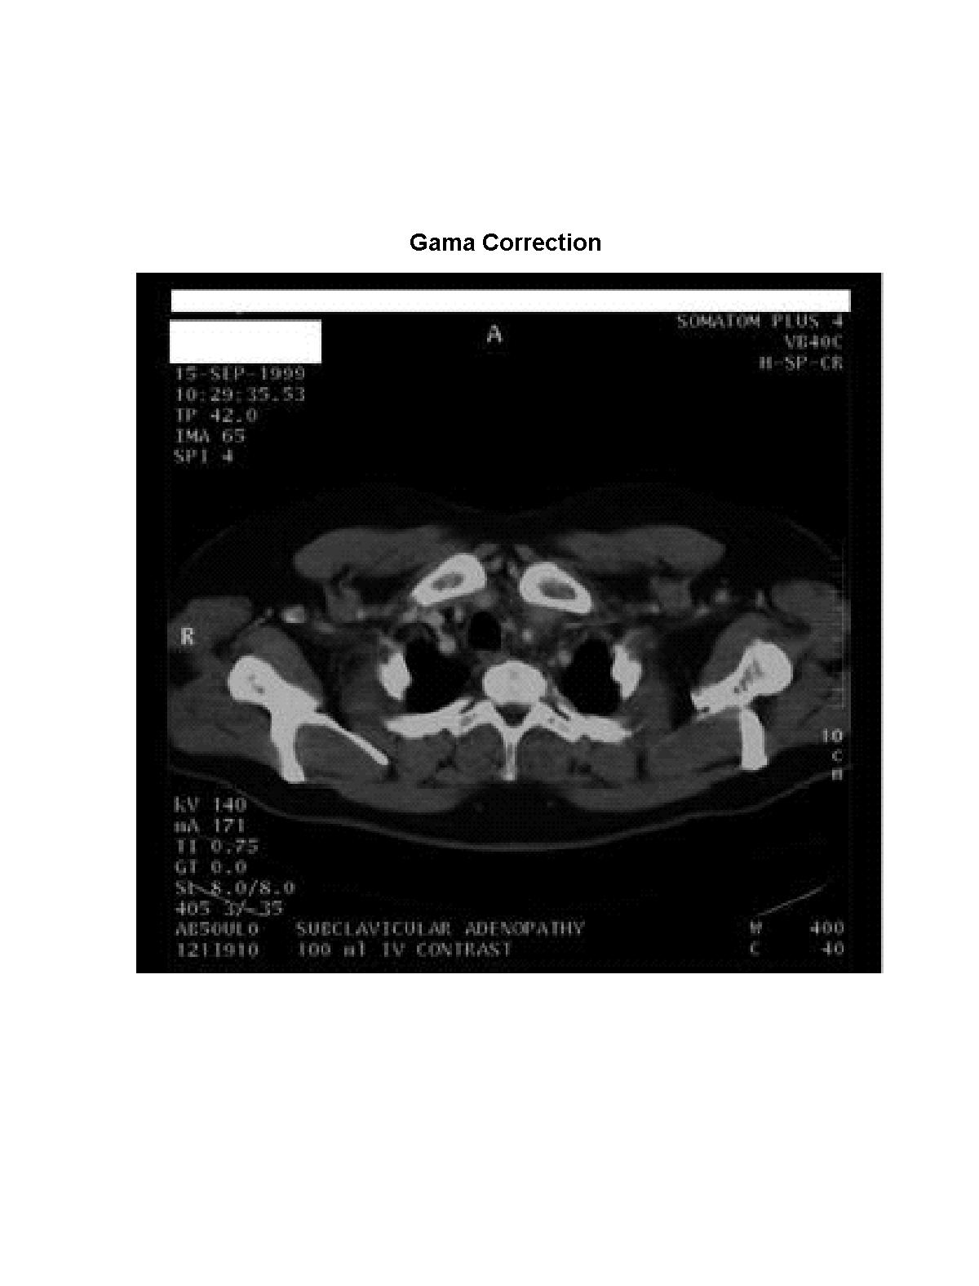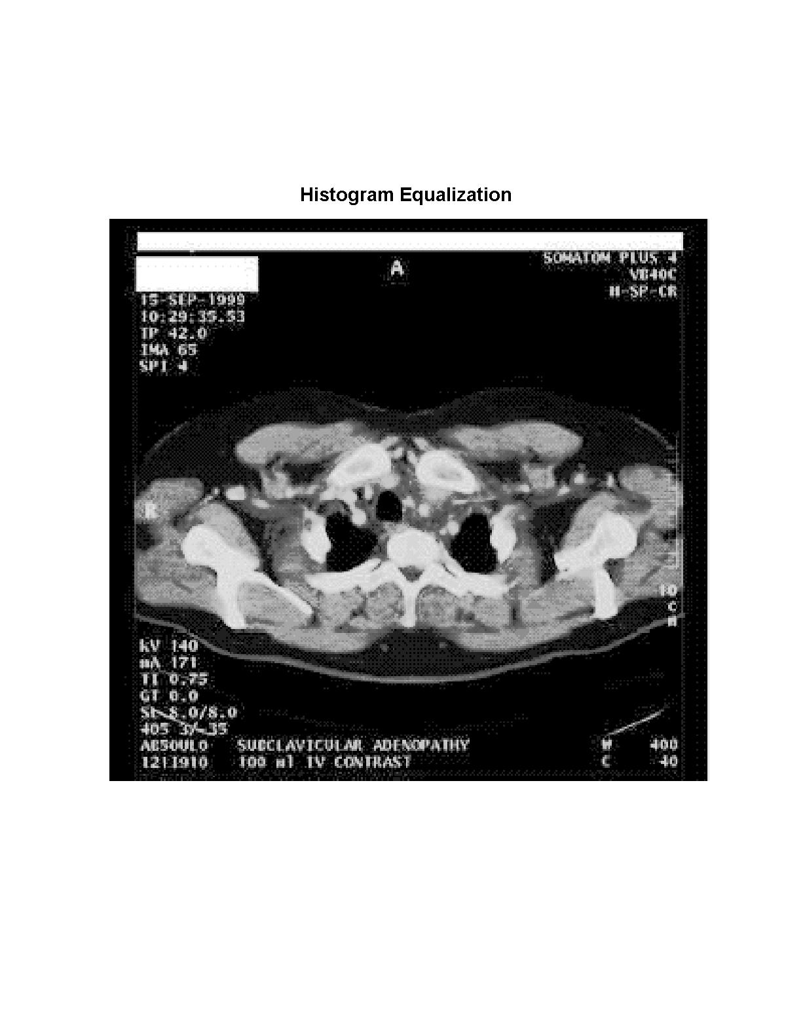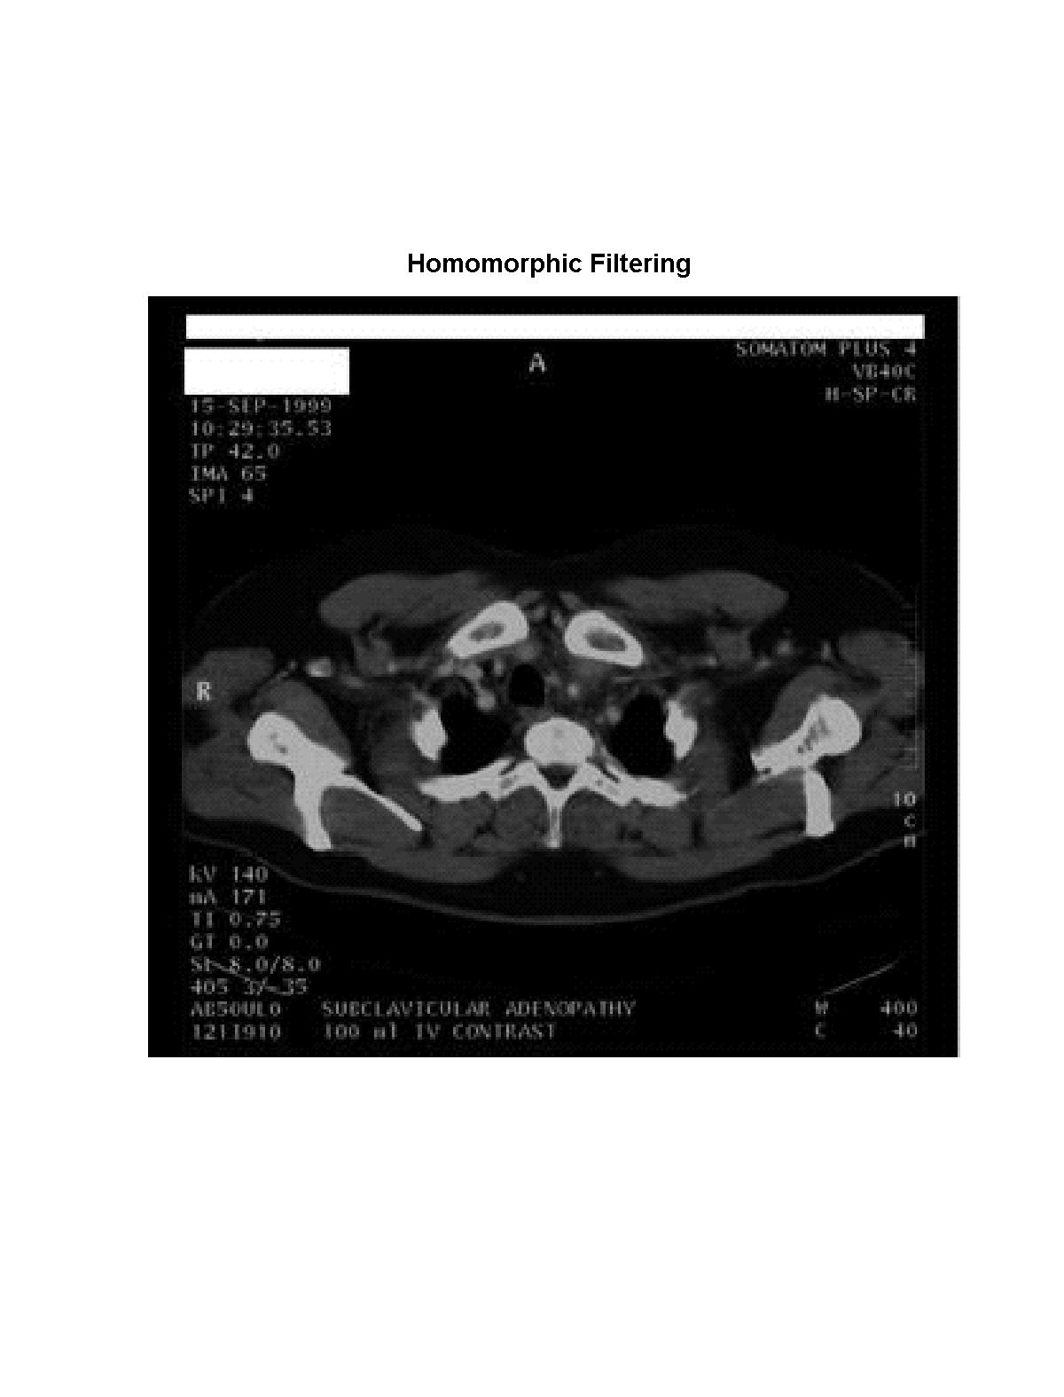
Fig. 6 Comparison of Retinex with other techniques (Example 2)
a
b
c
d
e
f
original image b) Retinex enhanced image c) Auto gain/offset d) Gama Correction e) Histogram equalization; f)Homomorphic filtering

[References]

1. E. Land, “An alternative technique for the computation of the designator in the retinex theory of color vision”, Proc. Nat. Acad, Sci., vol.83, P3078-3080, 1986
2. “Recent advances in retinex theory and some implications for cortical computations,” Proc. Nat. Acad. Sci. Vol. 80, pp. 5163-5169, 1983
3. “Recent advances in Retinex theory,” Vis. Res., vol.26, pp. 7-21,1986.
4. A.C. Hurlbert, “Formal connections between lightness algorithms,” J. Opt. Soc. Amer. A, vol. 3, pp. 1684-1693,1986
5.D. J. Jobson, Z. Rahman, and G. A. Woodell, "Properties and Performance of a Center/Surround Retinex," IEEE Transactions on Image Processing, March 1997
6.D. J. Jobson, Z. Rahman, and G. A. Woodell, "A Multi-Scale Retinex For Bridging the Gap Between Color Images and the Human Observation of Scenes," IEEE Transactions
7.Z. Rahman, G. A. Woodell, and D. J. Jobson, "A Comparison of the Multiscale Retinex With Other Image Enhancement Techniques,'' Proceedings of the IS&T 50th Anniversary Conference, May 1997

